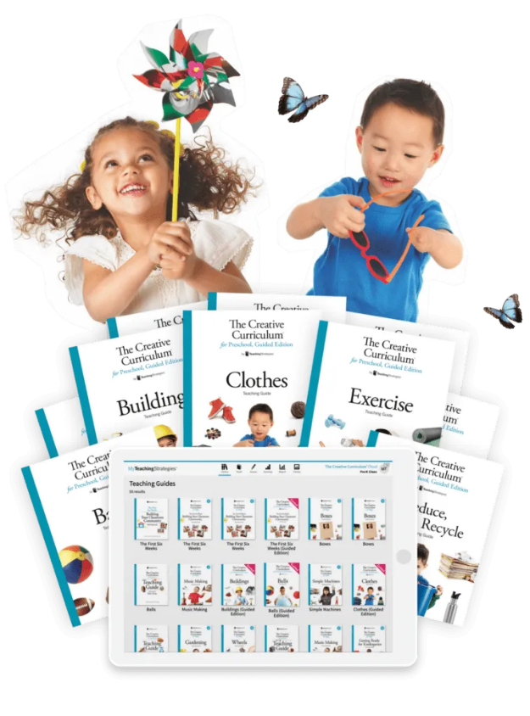

The Creative Curriculum for Preschool empowers children to be confident, creative, and caring learners through play-based, hands-on investigations- a research-based approach that incorporates language, literacy, and mathematics.

Learn more about the curriculum using the link below:

https://teachingstrategies.com/product/the-creative-curriculum-for-preschool/